Resources: Page 
The page resource allows you to create a simple web page on your course home page. You can add graphics, embed YouTube video clips, embed sound files, and include links to other sites.

Contents
- Add a Page
- Edit a Page
- Delete a Page
- Notes

Add a Page
- Go to the course home page.
- Click on the Turn editing on button.

- Click Add an activity or resource.
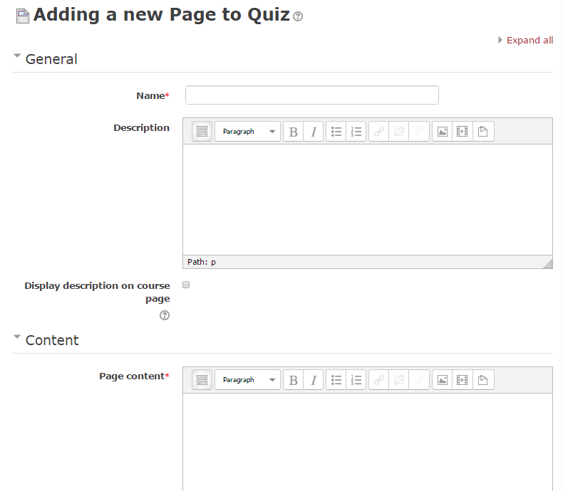
- Click on the radio button next to Page and click on the Add button.
The "Adding a new Page" page will appear.
Make your page interesting. Think about adding graphics, embedded videos, tables, etc., as well as text.

- Enter a Name, Description (optional), and Page content.
- Click on the Save and return to course or Save and display button.

Edit a Page
- Go to the course home page.
- Click on the Turn editing on button.
- Click Edit next to the Page resource.
- Click Edit settings.

Delete a Page
- Go to the course home page.
- Click on the Turn editing on button.
- Click on Delete.

Notes:
For additional information, check the Moodle Docs Page Resource or contact Moodle Help.

